1.1 Logical Scheme
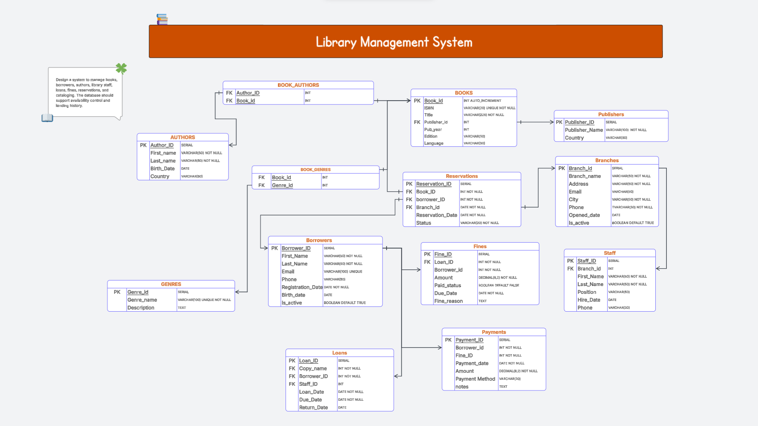

1.2 Objects

AUTHORS
This table stores detailed information about the authors of the books in the library system.

Table Name | Field name | Field Description | Data Type / Constraints
AUTHORS | Author_ID | Unique identifier for each author | INT, PK, AUTO_INCREMENT
 | First_name | Author's first name | VARCHAR(50), NOT NULL
 | Last_name | Author's last name | VARCHAR(50), NOT NULL
 | Birth_Date | Author's date of birth | DATE
 | Country | Author's country of origin | VARCHAR(50)

• The AUTHORS table is linked to the BOOK_AUTHORS bridge table via a One-to-Many (1:N) relationship.
• This structure allows the system to support a Many-to-Many (M:N) relationship between authors and books, meaning one author can write multiple books, and one book can have multiple authors.

Example with data
Author_ID | First_name | Last_name | Birth_Date | Country
1 | Александр | Пушкин | 1799-06-06 | Россия

BOOKS
This table stores detailed information about the book editions available in the library.

Table Name | Field name | Field Description | Data Type / Constraints
BOOKS | Book_id | Unique identifier for the book | INT, PK, AUTO_INCREMENT
 | ISBN | International Standard Book Number | VARCHAR(20), UNIQUE, NOT NULL
 | Title | Full title of the book | VARCHAR(225), NOT NULL
 | Publisher_id | Reference to the publisher | INT, FK
 | Pub_year | Year of publication | INT
 | Edition | Edition number or type | VARCHAR(20)
 | Language | Language of the book | VARCHAR(50)
• BOOKS — PUBLISHERS: A Many-to-One relationship where each book is linked to a specific publisher via Publisher_id.
• BOOKS — BOOK_AUTHORS: A relationship used to link books with their respective authors through a bridge table.
• BOOKS — BOOK_GENRES: A relationship used to categorize books into various genres.

Example with data
Book_id | ISBN | Title | Publisher_id | Pub_year | Edition | Language
101 | 978-0140449136 | Crime and Punishment | 50 | 2002 | 1st Edition | English

Publishers
This table contains information about the publishing companies that produce and release books.

Table Name | Field name | Field Description | Data Type / Constraints
Publishers | Publisher_id | Unique identifier for the publisher | INT, PK, AUTO_INCREMENT
 | Publisher_Name | Official name of the publishing company | VARCHAR(100), NOT NULL
 | Country | Country where the publisher is located | VARCHAR(50)

• Publishers — Books: A One-to-Many (1:N) relationship where one publisher can release multiple books.
• The Publisher_ID acts as a Foreign Key (FK) in the Books table to identify the source of the publication.
Example with data
Publisher_ID | Publisher_Name | Country
1 | Penguin Books | UK

GENRES
This table classifies the literary genres to which the books in the library belong
Table Name | Field name | Field Description | Data Type / Constraints
GENRES | Genre_id | Unique identifier for the genre | SERIAL, PK
 | Genre_name | Unique name of the genre (e.g., Fantasy) | VARCHAR(100), UNIQUE, NOT NULL
 | Description | Brief description of the genre's characteristics | TEXT

• The GENRES table is linked to the BOOK_GENRES bridge table via a One-to-Many (1:N) relationship.
• This allows for a Many-to-Many (M:N) relationship between books and genres, meaning one book can be associated with multiple genres.

Example with data
Genre_id | Genre_name | Description
1 | Science Fiction | Литература о воображаемых технологиях и будущем

BORROWERS
This table stores information about registered library users who are authorized to borrow books.
Table Name | Field name | Field Description | Data Type / Constraints
BORROWERS | Borrower_ID | Unique identifier for the borrower | SERIAL, PK
 | First_Name | User's first name | VARCHAR(50), NOT NULL
 | Last_Name | User's last name | VARCHAR(50), NOT NULL
 | Email | User's email address | VARCHAR(100), UNIQUE
 | Phone | Contact phone number | VARCHAR(50)
 | Registration_Date | Date of library registration | DATE, NOT NULL
 | Birth_date | User's date of birth | DATE
 | Is_active | Account activity status | BOOLEAN, DEFAULT TRUE

• The Borrowers table serves as a parent table for Loans, Fines, and Reservations.
• A One-to-Many (1:N) relationship allows a single borrower to have multiple active loans or reservations at the same time.

Example with data
Borrower_ID | First_name | Last_name | Email | Registration_Date
1 | Science Fiction | Литература о воображаемых технологиях и будущем | alina@mail.kz | 2026-01-15

ReseRVATION

This table stores information about book reservations made by borrowers in library branches.
Table Name | Field name | Field Description | Data Type / Constraints
RESERVATIONS | Reservation_ID | Unique identifier of reservation | INT, PK
 | Book_ID | ID of the reserved book | INT, FK
 | Borrower_ID | Borrower who made the reservation | INT, FK
 | Branch_ID | Branch where the reservation was made | INT, FK
 | Reservation_Date | Date when reservation was created | DATE, NOT NULL
 | Status | Reservation status (Pending, Completed, Cancelled) | VARCHAR(20), NOT NULL

• RESERVATIONS is related to the Books,Borrowers , and Branches tables through foreign keys.
This allows borrowers to reserve books from specific library branches.
Example with data
Reservation_ID | Book_ID | Borrower_ID | Branch_ID | Reservation_Date | Status
1 | 12 | 4 | 2 | 2025-03-01 | Pending

BRANCHES
This table stores information about library branches.
Table Name | Field name | Field Description | Data Type / Constraints
BRANCHES | Branch_ID | Unique identifier of the branch | INT, PK
 | Branch_name | Name of the library branch | VARCHAR(50), NOT NULL
 | Address | Branch address | VARCHAR(200), NOT NULL
 | Email | Branch email address | VARCHAR(50)
 | City | City where branch is located | VARCHAR(50) NOT NULL
 | Phone | Branch contact phone | VARCHAR(50) NOT NULL
 | Opened_date | Date branch was opened | DATE
 | Is_active | Shows if branch is active | BOOLEAN, DEFAULT TRUE

• BRANCHES is connected with the STAFF and RESERVATIONS tables.
• One branch can have many staff members and multiple reservations
Ezample with data
Branch_ID | Branch_name | Address | Email | City | Phone | Opened_date | Is_active
1 | Central Library | 10 Main St | bm@library.com | London | 123456789 | 2010-05-10 | TRUE

STAFF
This table stores information about employees working in library branches.
Table Name | Field name | Field Description | Data Type / Constraints
STAFF | Staff_ID | Unique staff identifier | INT, PK
 | Branch_ID | Branch where staff works | INT, FK
 | First_Name | Staff first name | VARCHAR(50), NOT NULL
 | Last_Name | Staff last name | VARCHAR(50), NOT NULL
 | Position | Job position | VARCHAR(50)
 | Hire_Date | Date staff was hired | DATE
 | Phone | Staff contact phone | VARCHAR(20)

STAFF is related to the BRANCHES table through Branch_ID.

Staff_ID | Branch_ID | First_Name | Last_Name | Position | Hire_Date | Phone
1 | 1 | Assel | Balgabay | Librarian | 2023-06-01 | 555123456
FINES
This table stores information about fines issued to borrowers.
Table Name | Field name | Field Description | Data Type / Constraints
FINES | Fine_ID | Unique identifier of the fine | INT, PK
 | Loan_ID | Loan associated with the fine | INT, FK
 | Borrower_ID | Borrower responsible for the fine | INT, FK
 | Amount | Fine amount | DECIMAL(8,2), NOT NULL
 | Paid_status | Indicates if fine is paid | BOOLEAN
 | Due_Date | Deadline to pay the fine | DATE, NOT NULL
 | Fine_reason | Reason for fine | TEXT

• FINES is connected with the LOANS and BORROWERS tables.
• This allows the system to track penalties for overdue returns.
Example with data
Fine_ID | Loan_ID | Borrower_ID | Amount | Paid_status | Due_Date | Fine_reason
1 | 7 | 4 | 10.00 | FALSE | 2025-03-10 | Late return

PAYMENTS
This table stores information about payments made for fines.
Table Name | Field name | Field Description | Data Type / Constraints
PAYMENTS | Payment_ID | Unique identifier of payment | INT, PK
 | Borrower_ID | Borrower making payment | INT, FK
 | Fine_ID | Fine being paid | INT, FK
 | Payment_date | Date of payment | DATE, NOT NULL
 | Amount | Payment amount | DECIMAL(8,2), NOT NULL
 | Payment_Method | Method of payment | VARCHAR(20)
 | Notes | Additional payment notes | TEXT
• PAYMENTS is related to the FINES and BORROWERS tables.
• This allows tracking of all payments made for fines.
Example with data
Payment_ID | Borrower_ID | Fine_ID | Payment_date | Amount | Payment_Method | Notes
1 | 4 | 1 | 2025-03-05 | 10.00 | Card | Paid at library desk

LOANS
This table stores information about books borrowed by library users.
Table Name | Field name | Field Description | Data Type / Constraints
LOANS | Loan_ID | Unique identifier of loan | INT, PK
 | Copy_name | Book copy identifier | INT, FK
 | Borrower_ID | Borrower who borrowed the book | INT, FK
 | Staff_ID | Staff member who processed loan | INT, FK
 | Loan_Date | Date book was borrowed | DATE, NOT NULL
 | Due_Date | Return deadline | DATE, NOT NULL
 | Return_Date | Actual return date | DATE

• LOANS is related to BORROWERS and STAFF tables.
• If a book is returned after the due date, a fine may be generated.
Example with data
Loan_ID | Copy_name | Borrower_ID | Staff_ID | Loan_Date | Due_Date | Return_Date
1 | 18 | 4 | 1 | 2025-03-01 | 2025-03-14 | 2025-03-12

BOOK_AUTHORS
This is a junction table used to implement a Many-to-Many (M:N) relationship between books and authors.
Table Name | Field name | Field Description | Data Type / Constraints
BOOK_AUTHORS | Book_id | Reference to the book | INT, FK, Composite PK
 | Author_id | Reference to the author | INT, FK, Composite PK

• This table resolves the Many-to-Many relationship: one book can have multiple authors, and one author can write multiple books.
• It uses a Composite Primary Key consisting of Book_id and Author_id.

Example with data
Book_id | Author_id
101 | 1

BOOK_GENRES
This junction table implements a Many-to-Many (M:N) relationship between books and their literary genres.
Table Name | Field name | Field Description | Data Type / Constraints
BOOK_GENRES | Book_id | Reference to the book | INT, FK, Composite PK
 | Genre_id | Reference to the genre | INT, FK, Composite PK

• This table allows a single book to be categorized under multiple genres simultaneously.
• It links the BOOKS table and the GENRES table.
• The combination of Book_id and Genre_id forms a Composite Primary Key, ensuring no duplicate genre assignments for the same book.
Example with data
Book_id | Genre_id
101 | 1

